Hotel Booking Form
CAADENCE Conference
Budapesti Műszaki és Gazdaságtudományi Egyetem
Műegyetem rakpart 3.
1111,Budapest (Hungary), 15-19.06.2016

Please return to Mercure Budapest Duna***(Under rebranding to Ibis Styles Budapest City):
H2025-re@accor.com H-1095 Budapest, Hungary, Soroksári út 12.
Tel:+36 1 455-83-40 or Fax: 36 1 455-83-85
Contact: Judit Fazekas
no later than 15. April., 2016. Reservations will be confirmed within 24 hours of receipt. After this date (15.04.2016.) the hotel reserves the right to confirm bookings subject to availability.

Please mark with an X which room type you wish to reserve.
Room rates include the buffet breakfast, VAT and 4 % City tax.
Standard room single occupancy |  | 70 EUR ,-/room/night
Standard room double occupancy |  | 70 EUR ,-/room/night
Smoking Room |  | Non smoking Room

⁭⁭Arrival date: |  | Departure date:
Last name: |  | First name:
Phone: |  | Country:
Fax: |  | E-mail:
⁭
Payment for accommodation should be made directly to the hotel. In order to guarantee your room reservation please provide the following credit card information. Without these details we cannot accept and confirm the reservation.

Credit card type: (Visa, Amex, Mastercard, JCB accepted) | Number: | Expiry date:
I agree that in case of no show the cost of 1 night will be charged - unless notice of cancellation is communicated 7 days prior to arrival.
Date: | Print Full Name: | Signature/Authorization:

Reservation nr. | Date of Confirmation | Confirmed by:

Map from the MERCURE Budapest Hotel to the conference location: Budapesti Műszaki és Gazdaságtudományi Egyetem

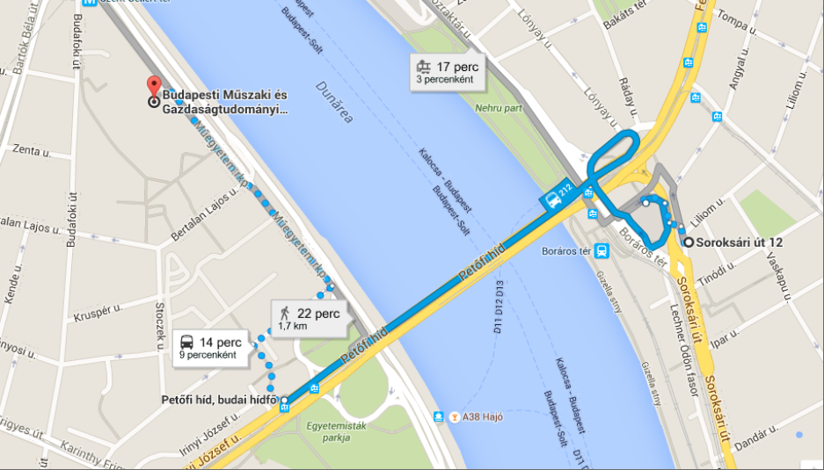

Pictures about the accommodation: MERCURE Budapest Duna***-under rebranding to Ibis Styles Budapest City *** Superior

